**Weapon system:**

Make different visual effects happen if attacked:

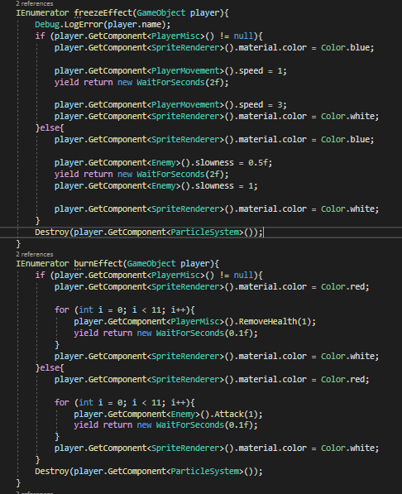

Add enemy artwork:

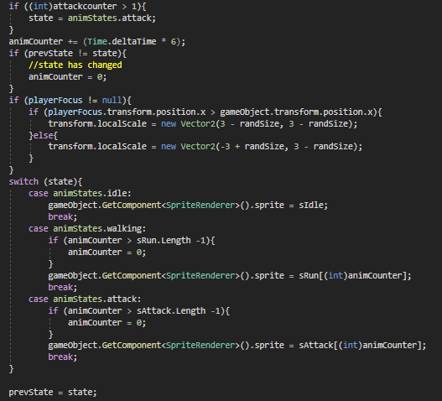

I duplicated the code for the boss too.

Add background to inventory:

Lock trigger selection to available only:

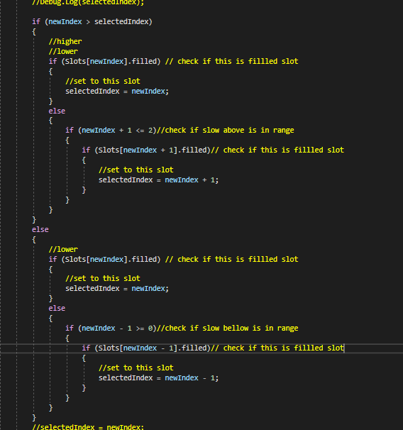

Prevent the jump after wall jump is complete:

[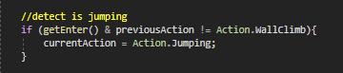](about:invalid#zClosurez)

Mage projectile:

Fix archer damage bug

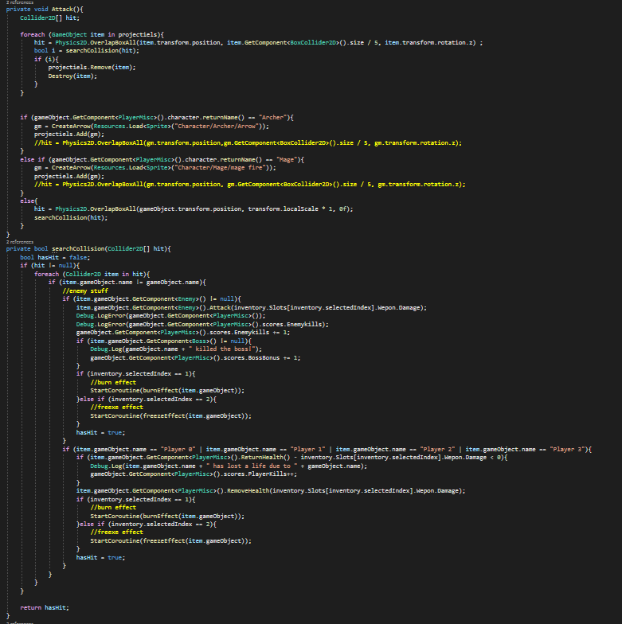

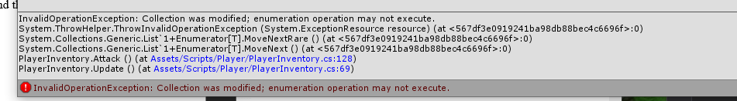

This gave a error. It was fixed by adding the removed items to a list to be removed in a new loop.

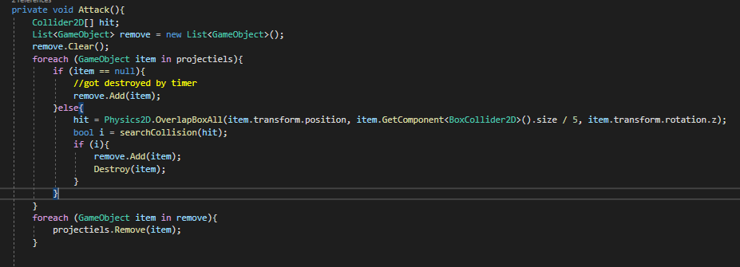

Respawn at the next level:

Remove freeze and burn weapon after a specific time?

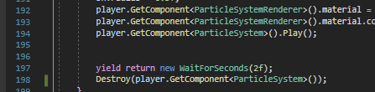

Hide inventory and text while paused

Download scores:

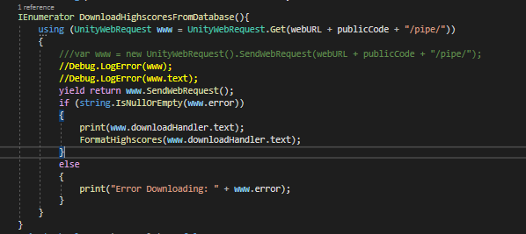

Movement considering environment ground

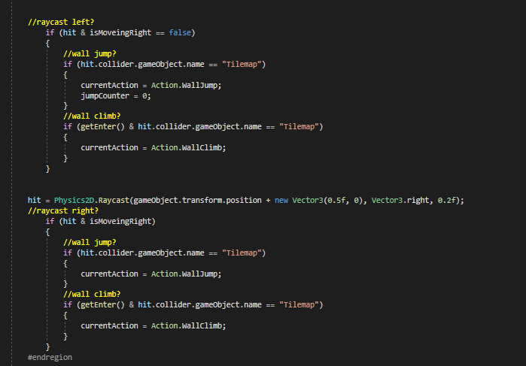

Add more levels:

I set it to select a random level between 2 and 4 to create infinite levels by reusing scenes.



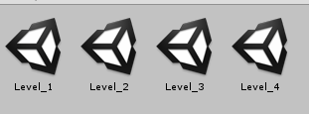

Add sound effects:////////////////////////////////////

As toby didn't have the needed software. I converted all the sounds from M4A. To something, unity could read such as WAV. And also do light editing to trim out the effect

 Ensure controller number references are fixed:

 I had I lot of loops where for testing I had put the length of the for the loop at 4. Instead of referencing the number of valid controllers. I went through and fixes this.

 Add updated pickup animations

Set menu music to play options

Disable movement in the selection screen:

 Fixing errors and warnings

OnLevelLoad function:

 WWW is obsolete:

Curl Error:

I had previously tried to research into this topic, but after looking into it more, I found that this is an issue specifically with the version of Unity I am using. And the only way to fix it would be to change my version. Therefore this is unfixable.

Colour error:

Misc warning issues:

C:\Users\Owner - Pudge\AppData\Local\Microsoft\Windows\INetCache\Content.MSO\8E47F2FB.tmp

C:\Users\Owner - Pudge\AppData\Local\Microsoft\Windows\INetCache\Content.MSO\7CD301C1.tmp

C:\Users\Owner - Pudge\AppData\Local\Microsoft\Windows\INetCache\Content.MSO\F53EEA77.tmp

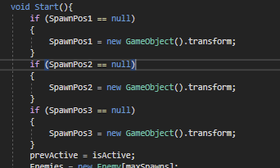

C:\Users\Owner - Pudge\AppData\Local\Microsoft\Windows\INetCache\Content.MSO\760DFBB3.tmp

This was simply a case of deleting any duplicated public items

C:\Users\Owner - Pudge\AppData\Local\Microsoft\Windows\INetCache\Content.MSO\19F0E339.tmp

[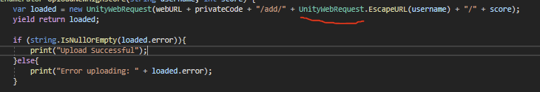](about:invalid#zClosurez)Was still have issues with WWW being obsolete. Discovered I left WWW.EscapeURL. So changed it to UnityWebRequest

C:\Users\Owner - Pudge\AppData\Local\Microsoft\Windows\INetCache\Content.MSO\3C04EF95.tmp

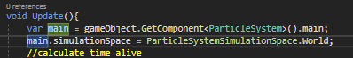

C:\Users\Owner - Pudge\AppData\Local\Microsoft\Windows\INetCache\Content.MSO\B402F3B1.tmp

This is an issue with visual studio. It has no impact on gameplay.

C:\Users\Owner - Pudge\AppData\Local\Microsoft\Windows\INetCache\Content.MSO\1B57E1E7.tmp

This was fixed by simply setting a default value. Had the same issue with the ground position array, so I sets its default value to null which would be overridden in the inspector.

C:\Users\Owner - Pudge\AppData\Local\Microsoft\Windows\INetCache\Content.MSO\CDD48B8D.tmp

C:\Users\Owner - Pudge\AppData\Local\Microsoft\Windows\INetCache\Content.MSO\75683223.tmp

